Chemistry 141 Name
Dr. Cary Willard
Exam 2A March 24, 2011

Multiple Choice (30 points)

Page 1 (19 points)

Page 2 (17 points)

Page 3 (15 points)

Page 4 (16 points)

Page 5 (20 points)

Total (117 points)

Chemistry Formulas

Kinetic energy = ½ mv²
w = -PΔV
P_{total} = P₁+P₂+P₃+…
u = (3RT/MW)^{½}
ΔG = ΔH - TΔS
PV = nRT
Rate ∝ (MW)^{-½}
P₁=X₁*P_{total}
C = q/ΔT
P_{total} = P₁ + P₂ + P₃ + …
M = mol/L
K = ºC + 273.16
w=dxF
E = mc²

HΨ=EΨ
$$E=nhν$$
$$c=λν$$
M₁V₁ = M₂V₂
P_{total} = P₁ + P₂ + P₃ + …
M = mol/L
$$\frac{{Rate}_{1}}{{Rate}_{2}}=\sqrt{\frac{{MW}_{2}}{{MW}_{1}}}$$
$$\left(P+\frac{n^{2}a}{V^{2}}\right)\left(V-nb\right)=nRT$$
$$λ_{deBroglie}=\frac{h}{mv}$$
$$ΔxΔmv≥\frac{h}{4π}$$

Constants
h = 6.626 x 10⁻³⁴ J sec
c= 2.9979 x 10⁸ m/sec
e = 1.602 x 10⁻¹⁹ C
N_{A} = 6.022 x 10²³/mol
k = 1.381 x 10⁻²³ J/K
K = ºC + 273.16
1 kcal = 4.184 kJ
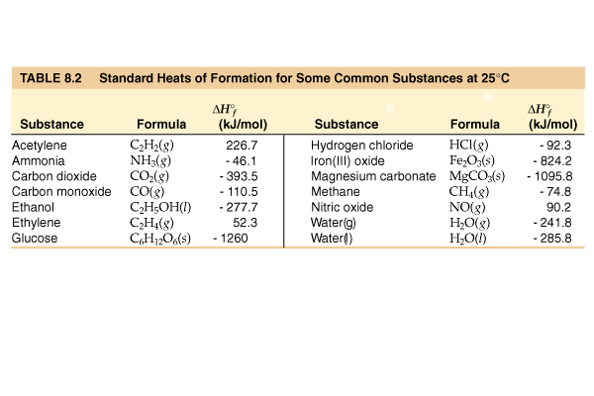
R = 0.0821 L atm/mol K = 62.4 L torr/mol K = 8.31 kJ/mol K
Standard Temperature and Pressure = 0ºC and 1 atm
760 torr = 760 mm Hg = 1.00 atm = 101 kPa = 14.6 psi = 30 in Hg
Specific heat water = 4.184 J/g K
Specific heat Al = 0.902 J/ g K
Specific heat Cu = 0.385 J/g K
ΔH_{vaporization} (H₂O) = 2260 J/g
ΔH_{fusion} (H₂O) = 333 J/g

mass electron = 9.109 x 10⁻³¹ kg

Average Bond dissociation Energies (kJ/mol)
H—H 436* | C—H 410 | N—H 390 | O—H 460 | F—F 159*
H—C 410 | C—C 350 | N—C 300 | O—C 350 | Cl—Cl 243*
H—F 570* | C—F 450 | N—F 270 | O—F 180 | Br—Br 193*
H—Cl 432* | C—Cl 330 | N—Cl 200 | O—Cl 200 | I—I 151*
H—Br 366* | C—Br 270 | N—Br 240 | O—Br 210 | S—F 310
H—I 298* | C—I 240 | N—I | O—I 220 | S—Cl 250
H—N 390 | C—N 300 | N—N 240 | O—N 200 | S—Br 210
H—O 460 | C—O 350 | N—O 200 | O—O 180 | S—S 225
H—S 340 | C—S 260 | N—S | O—S 364
C=C 611 | C=O 732 | O=O 498* | O=S 535 | N=O 598
C≡C 837 | C≡N 891 | N≡N 946*
*Bond dissociation energies for diatomic molecules are exact.
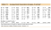
Part I -- Multiple choice questions (30 points)

- According to the kinetic molecular theory, the pressure of a gas in a container will increase if the
  - number of collisions with the container wall decreases.
  - number of moles of the gas decreases.
  - volume of the container increases.
  - temperature of the gas increases.

- Which statement about real gases is true?
  - Forces of attraction and repulsion exist between gas particles at close range.
  - The mass of the gas particles is zero.
  - The behavior of real gases can be exactly predicted using the ideal gas law.
  - The volume of the gas particles is zero.

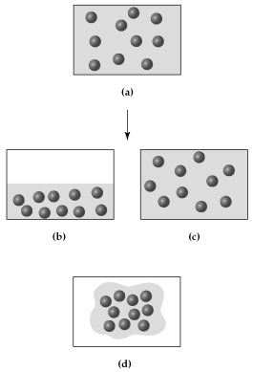
- Assume that you have a sample of gas at 300 K in a sealed container, as represented in (a).

Which of the drawings (b)-(d) represents the gas after the temperature is lowered from 300 K to 200 K?
  - Drawing b
  - Drawing c
  - Drawing d

- The nutritional calorie (abbreviated Cal) is equal to

  - 1 kcal
  - 4.184 J
  - 4.184 cal
  - 1000 kcal

- For most chemical reactions
  - ΔE is much larger than ΔH.
  - ΔH is equal to ΔE.
  - ΔH is much larger than ΔE.
  - the difference between ΔH and ΔE is very small.

- For a particular process that is carried out at constant pressure, 125 kJ of heat is released and 15 kJ of work is done. Therefore,

  - ΔE = −110 kJ and ΔH = −125 kJ.
  - ΔE = −125 kJ and ΔH = 140 kJ.
  - ΔE = −140 kJ and ΔH = −125 kJ.
  - ΔE = −125 kJ and ΔH = −110 kJ.

- For which should the standard heat of formation ΔHºf, be zero at 25ºC?

  - O (g)
  - O₂ (g)
  - O₃ (g)
  - All of the above

- The values of ΔHºf for the three states of benzene are approximately -22 kcal/mol, -11 kcal/mol, and 20 kcal/mol. Which is the value for solid benzene?
  - −22 kcal/mol
  - 20 kcal/mol
  - −11 kcal/mol
  - cannot be determined without additional information

- Which equation represents the reaction whose ΔH, represents the standard enthalpy of formation of CHCl3(l) at 25ºC? (i.e., for which is ΔH = ΔHºf of CHCl3)
  - CHCl3(l) C(s) + H(g) + 3 Cl(g)
  - C(s) + H(g) + 3 Cl(g) CHCl3(l)
  - C(s) + 1/2 H2(g) + 3/2 Cl2(g) CHCl3(l)
  - 2 C(s) + H2(g) + 3 Cl2(g) 2 CHCl3(l)

- Some assumptions from the kinetic molecular theory are listed below. Which one is most frequently cited to explain compressibility of a gas?
  - A gas consists of tiny particles moving in random straight line motion.
  - The average kinetic energy of gas particles is proportional to the Kelvin temperature.
  - Collisions of gas particles are elastic and total kinetic energy of the gas is constant.
  - The volume of the particles is negligible compared to the volume of the gas.
  - None of the above’

- You are given two flasks of equal volume. One contains H2 at 0ºC and 1 atm while the other contains CO2 at 0ºC and 2 atm. Which of the following quantities will be the same for both flasks?
  - average molecular speed
  - number of molecules present
  - density
  - average molecular kinetic energy
  - both a and d are correct

- Which one of the following gases will have the highest rate of effusion?
  - N2O
  - NO2
  - NO3
  - N2O4

- The process of forming a bond between two elements
  - depends on each elements heat of formation
  - is generally an endothermic process
  - occurs only under laboratory conditions
  - has a positive heat of reaction
  - has a negative heat of reaction

- A quantized variable
  - can only assume certain values.
  - consists of photons.
  - is extremely small.
  - can be continuously varied.
  - has units of joules

- The intensity of a beam of light is related to its

  - frequency.
  - wavelength.
  - relative number of photons.
  - speed.
  - none of the above

Part II -- Problems (79 points)

- (4 points) Carry out the following conversions
  - 525 torr to kPa

  - 0.573 atm to mm Hg

- (5 points) A sample of argon gas has a volume of 6.88 L and a pressure of 0.834 atm at 25.0ºC. If the pressure increases to 6.06 atm and the temperature increases to 110.0ºC, what is the final volume?

- (5 points) Use kinetic molecular theory to explain the change in pressure that results from warming a sample of gas.

- (5 points) What is the pressure in millimeter of mercury inside a container of gas connected to a mercury-filled open-end manometer when the level in the arm connected to the container is 24.6 cm lower than the level in the arm open to the atmosphere and the atmospheric pressure reading outside the apparatus is 778.3 mm Hg?
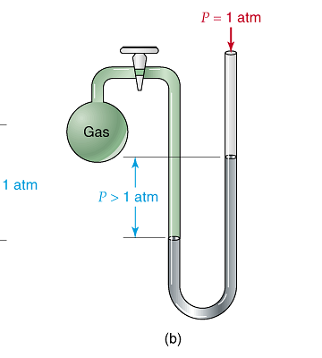

- (12 points) A hydrocarbon has a density of 3.58 g/L at a temperature of 25ºC and a pressure of 1.50 atm.
  - Determine the molar mass of the hydrocarbon

Molar mass = ______________

  - If there is a leak in the tank containing the hydrocarbon, how long will it take for 1 mol of the hydrocarbon to effuse. A sample of argon gas effuses from the same tank at a rate of 1 mol/6.3 days.

- (5 points) You hold a gram of copper in one hand and a gram of aluminum in the other. Each metal was originally at 0ºC. (Both metals are in the shape of a little ball that fits into your hand.) If they both take up heat at the same rate, which will warm to your body temperature first? Explain your reasoning.

- (6 points) Given the reaction
3 Fe₂O₃(s) + CO(g) 2 Fe₃O₄(s) + CO₂(g) ΔH = -46 kJ
determine the ΔH for the following reactions

Fe₂O₃(s) + ¹/₃ CO(g) ²/₃ Fe₃O₄(s) + ¹/₃ CO₂(g)

4 Fe₃O₄(s) + 2 CO₂(g) 6 Fe₂O₃(s) + 2 CO(g)

- (9 points) The bombardier beetle uses an explosive discharge as a defense mechanism. The chemistry of the reaction involved is the oxidation of hydroquinone by H₂O₂ to produce quinone and water.
C₆H₄(OH)_{2(aq)} + H₂O_{2(aq)} C₆H₄O_{2(aq)} + 2 H₂O_{(l)}

Given the following reactions, calculate ΔH.

C₆H₄(OH)_{2(aq)} C₆H₄O_{2(aq)} + H_{2(g)} ΔH = + 177.4 kJ
H_{2(g)} + ¹/₂O_{2(g)} H₂O_{(g)} ΔH = − 241.8 kJ
H_{2(g)} + O_{2(g)} H₂O_{2(aq)} ΔH = −191.2 kJ
H₂O_{(g)} H₂O_{(l )} ΔH = − 43.8 kJ

How much heat is produced by a bombardier beetle that produces 25.0 mg of quinine?

- (16 points) A sample of an unknown metal was reacted with 150.0 g of hydrochloric acid in a calorimeter.
  - If a 5.103 g sample of the metal caused the temperature of the calorimeter and its contents to rise from 15.4ºC to 56.3ºC, calculate the heat of reaction per g for the metal. (The acid solution has a specific heat of 4.168 J/g K, and the calorimeter has a heat capacity of 39.2J/K.)

  - The hydrogen gas from the experiment above was collected in a 3.50 L container at 30.0ºC and 794 torr pressure, how many moles of hydrogen were collected?

  - What is the molar mass of the metal? (Previous experiments have shown the metal to form a chloride of the formula MCl₃. Write a balanced chemical reaction and determine how many moles of the metal reacted.)

  - Calculate the molar heat of reaction of the metal.
- (6 points) The standard enthalpy of combustion of cyclohexane (C₈H₁₆) is −1186.0 kJ/mol. The products of this combustion are liquid water and carbon dioxide gas. Calculate the standard enthalpy of formation of liquid n-heptane
C₈H₁₆(g) + 12 O₂(g) ⎯→ 8 CO₂(g) + 8 H₂O(l)

- (9 points) The blue color of the sky results from the scattering of sunlight by air molecules. The blue light has a frequency of about 7.5 x 10¹⁴ Hz.
  - Calculate the wavelength, in nm, associated with this radiation.

  - Calculate the energy, in J, of a single photon associated with this frequency.

  - The retina of a human eye can detect light when radiant energy incident on it is at least 4.0 x 10⁻¹⁷ J. How many photons of “sky blue” light does this correspond to?

- (5 points) The ionization energy of vanadium is 650. kJ/mol. Calculate the wavelength of light that will just ionize an atom of vanadium.

